**Steelco Production Schedule Optimization**

Blake Conrad

BC Consulting

11 February 2018

# Executive Summary

## Overview

Steelco has inquired that BC Consulting examine their company steel production schedule for an eight-week period to minimize waste and cost. Steelco manufactured I beams, nails, and rebarb in varying capacities and demands last year to produce $2.5 million in profits. With suggested production schedule implementations presented, Steelco could increase their profits 12.2% next year reach profits as high as $2.82 million.

The profit margin mentioned above is the outcome of minimizing costs relating to storing inventory and placing backorders. With integration of higher production capacities or an e-commerce approach to selling and distributing demands, Steelco could approach even higher profits.

## Recommendation

After examining demands mentioned in the *Memorandum of Understanding* BC Consulting constructed a production schedule illustrated in *Table 1*. The following table will enable Steelco to reach profits as high as $2.82 million next fiscal year. There is a considerable chance that demands, production suppliers, and products will change over time. In the case that any of these occur, BC Consulting recommends to consult an Industrial Engineer to re-run results with new data or reach back out to BC Consulting to re-structure the model.

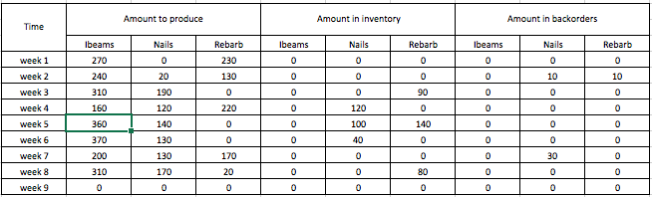

*Table 1*: *Steelco recommended production schedule.*

# Technical Report

## Assumptions

Backordered customers are not lost

Demands stay the same

Production costs stay the same

Production capacities stay the same

Customer fees and charges stay the same

## Time series

Time could be spread out even further

## Decision Variables

Build a table of DV

## Constraints

Math out the constraints

## Objective Functions

Math out the objective

## Results

Clearly express the output from LINGO and Table 1

## Sensitivity Analysis

Look at slacks on constraints and see if they would have made any impact

## Conclusion and Recommendation

Repeat yourself